

STARTER Project
Funding Application



Objectives of the AMCRC

Bringing together Australia’s significant additive manufacturing (AM) research community and ambitious companies, the AMCRC aims to establish a world-class AM ecosystem spanning the entire value chain. This will enable industry to accelerate innovation, explore new business models, harness sustainable materials, and certify production. In turn, it will drive widespread industrial adoption of AM technologies, empowering our partners to design, manufacture, and succeed.

In the longer term, this will significantly enhance Australia’s industrial productivity, conserve resources, strengthen future resilience, and expand a highly skilled workforce.

AMCRC funding begins in mid-2025 and will run for seven years, supporting a wide range of industry-led manufacturing R&D projects. With $57.5 million in Commonwealth funding, matched by industry contributions, AMCRC will catalyse additive manufacturing research and development across the entire value chain.

STARTER Project – R&D Funding Opportunity

We welcome collaborative projects of 3 - 12 months from existing AMCRC industry partners and new industry partners seeking to collaborate with one or more of our research partners.

- Project total cash value must be between $40,000 - $150,000.
- Projects should run for 3 - 12 months in duration.
- Projects should align with one or more AMCRC research programs, involve additive manufacturing and surface technologies as key drivers for successful outcomes, and address Australian national industry and science priorities. Projects should also leverage advanced business models and opportunities wherever possible.

Applying for AMCRC STARTER Project Funding

- Registered Australian businesses may be eligible to receive AMCRC project funding. Applicants must meet AMCRC’s evaluation criteria and be approved by AMCRC.

- All recipients of AMCRC project funding will be required to enter into a contractual agreement with AMCRC and the project parties. This agreement will define the terms and conditions under which funding is provided, and recipients must comply with its terms.

- AMCRC funds cannot be used to cover costs already funded by other government sources (Federal, State, or Territory).

- Once a formal and compliant project application is received by AMCRC - along with supporting documentation including a financial budget - it will typically be processed within 21 days, unless further information is required.

- Applications may be submitted to AMCRC at any time. See https://www.amcrc.com.au for details.

- AMCRC funding is subject to the continuity and availability of funding from the Commonwealth.

Partner/s Details

Industry Partner Details
Organisation:
ABN Number:
Website:
Email :
Mobile / Phone: | Mobile: Phone:
Industry Lead (Project Leader):
Signed (Authorised Officer)¹:
Authorised Officer Name/Position | Name: Position:
Date:

Research Partner Details
Organisation:
ABN Number:
Website:
Email :
Mobile / Phone: | Mobile: Phone:
Research Lead (Project Leader):
Signed (Authorised Officer)¹:
Authorised Officer Name/Position | Name: Position:
Date:

Project Start/Finish Date
Start Date:
Finish Date:

Project Budget for Term of Project
AMCRC Cash Contribution Request:
Industry Cash Contribution:
Total Staff In-kind Cash Value
Total Non-Staff In-kind Cash Value
Total Project Cash Value
Total Project Staff In-Kind (FTE)

Project Title and Description

Project Title
(100 Characters Maximum)

Project Overview / Description
Write as a single paragraph beginning with who is involved (i.e. partners), followed by what will be done, and why this is important to the Industry Partner and the broader Australian industry. (750 characters max)
(Character Count of 750 Including Spaces.)

Why, What and How

Problem / Opportunity
What problem, gap, or opportunity will this project address - The response should specifically address the industry problem, gap, or opportunity that the proposed science, engineering, and research will aim to solve and which cannot be known or determined in advance
(4500 characters max – 6 Points)
(Character Count of 4500 including Spaces)

Outcomes
Describe the key outcomes and explain how they will address the identified problem or opportunity within the industry partner’s context. (4500 characters max – 6 Points)
(Character Count of 4500 including Spaces)

R&D Plans Strategic Fit with AMCRC

Advanced Technologies and Innovations
Describe the advanced technologies and/or innovative approaches that will be adopted and explain what makes this project unique. (750 characters max – 1 Point)
(Character Count of 750 Including Spaces.)

Sustainable Manufacturing
How will the R&D contribute to sustainable manufacturing and digital transformation for the Industry Partners business if outcomes are adopted (750 characters max – 1 Point).
(Character Count of 750 Including Spaces.)

Collaboration
Describe how will effective collaboration between Industry and University partners be encouraged. (750 characters max – 1 Point).
(Character Count of 750 Including Spaces.)

Project Benefits

Benefits to Industrial Partner and Broader Industry

Industry Benefits & Commercial Potential
What is the anticipated return on investment (ROI), and commercial opportunity and broader benefits to the industry partner (e.g. market size, share, export potential, job creation, revenue generation, and IP utilisation)? - (1500 characters max – 2 Point).
AMCRC recommend Industry Partner to complete this question

Benefits to “Others”
What benefits will the project provide to broader Australian manufacturing and the community (e.g. supply chains, consumers, the public, and research organisations) - (1500 characters max – 2 Point).
AMCRC recommend Industry Partner to complete this question
(Character Count of 1500 including Spaces)

Industry Partner Priority
Provide evidence beyond the commitment to research and development activities within this application that this project is a strategic priority for the industry participant(s) (e.g. leadership buy-in, allocation of resources, financial commitment)? – (1500 characters max – 2 Point).
AMCRC recommend Industry Partner to complete this question
(Character Count of 1500 including Spaces)

Adoption & Utilisation

Adoption Strategy
Describe the Industry Partner’s plans to adopt the technology within their business, including where and how it will be used? (1500 characters max – 2 Points)
AMCRC recommend Industry Partner to complete this question
(Character Count of 1500 including Spaces)

Adoption Timeframe and Investment
What are the key steps, timeframe, and investment needed post-project to take the work from nominally prototype to real world application? (1500 characters max – 2 Points)
AMCRC recommend Industry Partner to complete this question
(Character Count of 1500 including Spaces)

Project Intellectual Property (PIP)

PIP expected from activities
Please identify any unique IP expected or likely to be developed as part of the research activities undertaken in this project. Examples include designs, software, methods/procedures, products, trade secrets and inventions. (750 characters max).

PIP Ownership
What arrangements have been agreed between the proposed project participants regarding ownership and utilisation of PIP created (if any) (750 characters max).

PIP Access

What access will other partners involved in the project have to the Project Intellectual Property (PIP)? If industry partners will not own the PIP, specify the terms under which they will be able to access and commercialise the outcomes at a future date. (750 characters max).

Background Intellectual Property (BIP)

BIP Required to Complete Research

Please specify any background IP required to complete the proposed research and development activities. (Include: Patents, Trademarks, Registered Designs, Design Rights, Circuit Layouts, Brands, Logos)

Registration Number  If applicable  (e.g. US 3,771,192) | BIP Name/Descriptor | Type | Author/Owner

Confidential Information to Complete Research

Please specify any Confidential Information (CI) required to complete the proposed research and development activities. Includes all trade secrets, know-how, financial information and other commercially or scientifically valuable information of whatever description and in whatever form (whether written, or oral, visible or invisible). Provide details e.g. Confidentiality Agreement, Report Reference etc.

Confidential Information Details | Reference  (If available) | Author/Owner

BIP and Confidential Information Conditions of Use

For each individual author/owner listed in section 8.1 above, please specify the conditions under which their BIP may be used in the project.

Author/Owner | Conditions under which their BIP may be used in the project

Key Researcher

Provide a brief overview of the two lead researchers, highlighting their relevant experience directly related to the project and previous collaborations within industry-led research and development initiatives.
Name:
Description of experience relative to project (750 characters max).
(Character Count of 750 including Spaces)

Risk Analysis \
List Top 3 risks only

Risk Identified |  |  | Risk Assessment |  |  | Risk Mitigation / Management
Category |  |  | Likeli- hood | Impact | Level | Solution
 | e.g. Tech | Machine capability no at level required for product/design | Pos. | Mod. | Mod. | Plan in-place to establish machine capabilities and adjust product/design if required.
1
2
3

Risk identification Categories
- Commercial (Com) Risk to company or product in the market; risk of competition;
risk associated with customers
- Emerging / Future (Fut) Risk from possible changes or future developments
- Financial (Fin) Risk to revenues, profit; risk of greater costs incurred
- Operational (Op) Risk in supply chain, contracting, sales, distribution,
administration including IT and operations
- Strategic (Strat) Risk to annual plan or company interest
- Technical (Tech) Risk in the knowledge base; risk of research failure; risk in
technology
- Other To be specified

Risk assessment
- Likelihood: Likely, Possible (Pos.), Rare
- Impact: Minor, Moderate (Mod.), Major
- Level of risk: Low, Moderate (Mod.), High

Risk mitigation and management
Description of proposed solution (and indicative cost) and whether it is already underway

Other Active & Recent Grants
AMCRC due diligence requires that the Commonwealth contribution for this research project is not matched with other government funding from Federal, State, or Territorial Government sources which the Industry Partner/s may have received. Therefore, we request that you list any current active grants, as well as any grants received in the past three years. Please note that grant history will not be considered when assessing projects eligibility for AMCRC funding. This information will only be used to ensure compliance with Commonwealth requirements when developing a project agreement, if funded.
Grant Type | Grant project Name / Description | Date Granted | Date Complete | $ Value

Supporting Information

The following supporting information is required when applying.

This information is for AMCRC internal review only and will be used to assess the company's suitability and risk for funding:
Supporting Information Required | Check

Industry Partner Company Management Organisation Chart

Industry Partner Ownership Structure

Company Financial Budget and Forecast

Most recent audited accounts or annual report (if available) or
management reports.

APPENDIX

APPENDIX A - Definitions of Manufacturing Readiness Levels (MRLs)
Manufacturing Readiness Level (MRL) is a measure developed by the United States Department of Defense (DOD) to assess the maturity of manufacturing readiness, similar to how Technology Readiness Levels (TRL) are used for technology readiness. The intent was to create a measurement scale that would serve the same purpose for manufacturing readiness as TRLs serve for technology readiness – to provide a common metric and vocabulary for assessing and discussing manufacturing maturity, risk and readiness. They can be used in general industry assessments, or for more specific applications in assessing capabilities of organisations, possible suppliers, etc.

MRLs are quantitative measures used to assess the maturity of a given technology, component or system from a manufacturing perspective. They are used to provide decision makers at all levels with a common understanding of the relative maturity and potential risks associated with manufacturing technologies, products, and processes being considered. Manufacturing risk identification and management should begin at the earliest stages of technology development, and continue vigorously throughout each stage of a program’s life-cycles.
MRLs were designed with a numbering system to be roughly congruent with comparable levels of TRLs for synergy and ease of understanding and use

MRLs provide a common language and standard, for example, in:
- Assessing the manufacturing maturity of a technology, product, or manufacturing process
- Understanding the level of manufacturing risk to produce a system or transitioning a technology into a system
- Integration of manufacturing into the acquisition process and milestone decisions
- Establishing the agenda for manufacturing risk management within existing Systems Engineering processes and technical reviews
- Achieving manufacturing maturity at critical acquisition decision points
- Pinpointing potential risk areas through independent Manufacturing Readiness Assessments (MRAs)

Manufacturing Readiness Assessments (MRAs) address these unanswered questions in order to reduce manufacturing risk. However, it still does not address the question of whether the product is reliable or maintainable.
The AMCRC sees particular benefit in the use by participants of TRL and MRL terminology and milestones in Project Plans, including:
- Common language and measurement across different projects
- Articulation of key AMCRC focus areas for both Research Projects and Business and Industry Transformation Projects
- Creating and managing IP Utilisation Plans, outcome planning and measurement, Project reporting, etc

Further Information Available at this link https://www.dodmrl.com/MRL_Deskbook_2022__20221001_Final.pdf

MANUFACTURING READINESS LEVELS – AMCRC ‘Fast-Track Projects’ PROJECT FOCUS IS MRL4 – MRL7
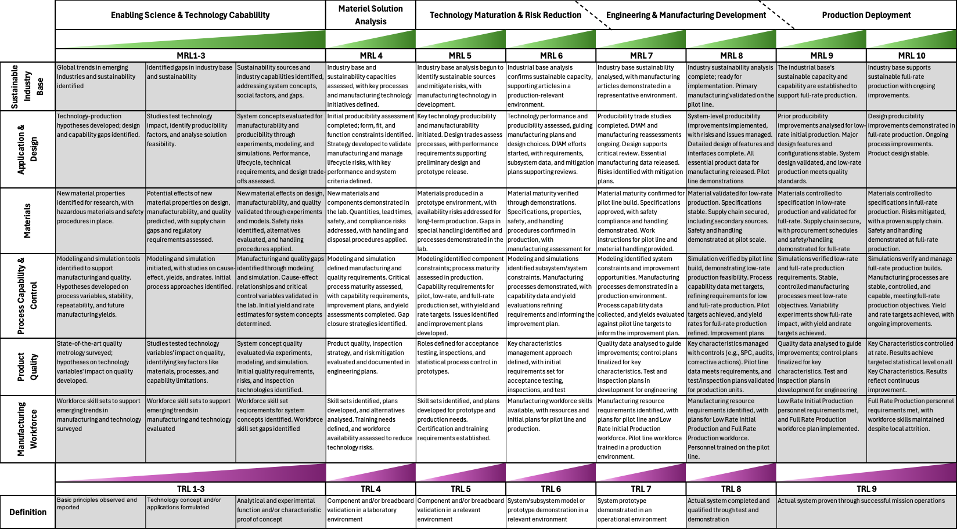

APPENDIX B - AMCRC ‘STARTER Preparation and Selection Processes

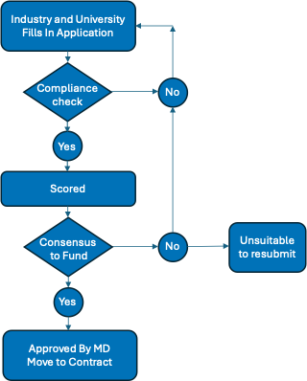

APPENDIX C - Overview of AMCRC Research Programs
Program 1.  Sustainable Manufacturing | 1.1 Sustainability-ESG Frameworks
Program 1.  Sustainable Manufacturing | 1.2 Human Factors and Industry 5.0
Program 1.  Sustainable Manufacturing | 1.3 Digital Ecosystem
Program 1.  Sustainable Manufacturing | 1.4 Industry Transformation
Program 2.  Application and Materials Development | 2.1 Advanced Metal Alloys
Program 2.  Application and Materials Development | 2.2 High Performance Polymers
Program 2.  Application and Materials Development | 2.3 Sustainable Materials
Program 2.  Application and Materials Development | 2.4 Construction Materials
Program 3.  Technology and Process Development | 3.1 Smart AM Technologies
Program 3.  Technology and Process Development | 3.2 Validation and Certification
Program 3.  Technology and Process Development | 3.3 Sovereign Manufacturing Capabilities in Feedstock and Post Processing
Program 3.  Technology and Process Development | 3.4 Optimised Energy Source Application
Program 4.  Surface Technologies and Post Processing | 4.1 Durable and Functional Surface Technology
Program 4.  Surface Technologies and Post Processing | 4.2 Repair and Remanufacture of Components
Program 4.  Surface Technologies and Post Processing | 4.3 Bioactive and Low Environmental Impact Surface Coatings
Program 4.  Surface Technologies and Post Processing | 4.4 Post Processing of AM Parts

